Developments:
New site set up
- Auto date box has gone
- On importing site matrix no ability to select ‘Configuration’. I.e. semi / Terrace / bungalow / 3 storey / FOG / Maisonette / Apartment.
- After creating and order (sub-con) and creating a payment certificate, the development Workspace still says ‘No Sub-Contract packages yet’:
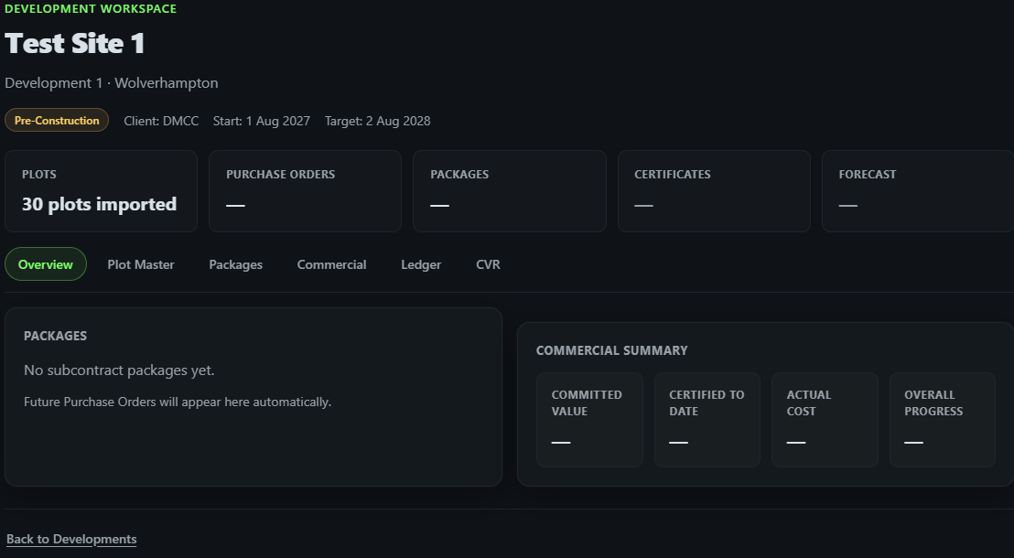

Orders:
- Not keen on the square edged white border around the main input box. Not as slick as the rest of the design
- After saving a supplier, how do I amend a mistake?
- Clauses on Sub-Con orders – Tick boxes are not aligned properly
- When cursor (select index finder icon) hovers over ‘Save & Send for Approval’ the green colour disappears where it doesn’t over the ‘save draft’ box. It still works but seems wrong
- PDF print still shows old legacy Cotswold Oak Logo. Needs default Buildlite for marketing purposes and the set-up wizard needs to bring in the new client’s logo. I think it does that on the set up visual but doesn’t pull through to the pdf yet.
- The PPD order has a good ‘approved’ box in the top right but just users the name ‘David’. Needs a full name and surname driven from the user profile (needs setting up). Like wise on the Approved by box in the bottom right corner.
- In fact we need to check over all PDFs produced in further development

Matrix:
- If there is a total on the matrix the import wizard brings it though and creates an error. It needs to see that and not double count otherwise its another admin task for the user.
- Deleted the row totals as well as the overall total but that has stopped the matrix import wizard working
- Column mapping isn’t picking up stages as on the uploaded matrix, i.e. base lift, 2nd lift. 3rd lift. If we have to default to Buildlite set stages, it will mean more admin and a large selection box to choose from on the ‘map y our columns’ section. It needs to be intuitive and use whatever matrix has been uploaded even if it differs from site to site. Yet stragely works when the total column is present!
Certificate:
- Column 2 ‘Type’ appears on the matrix with a £0.00 value sat in it. Either remove column or let is show the house type
- Certificate has brought VAT into the calc even though the order was set as zero VAT
- What actually happens with the cert once its approved. Is it to be sent to generate a PDF certificate? Can you do a whole payment run with each cert on one line for full release by the Commercial Director? Rather than going into each cert. That’s very time consuming. Then how does it all get present ed to accounts for payment input? Each pdf or again, a whole list line by line for them to populate their accounts system?
CVR:
- On first impression it looks like only actual raised orders generate a line in the CVR. WE need to import a ‘budget’ which will have come from an approved land appraisal. This ideally should be another excel upload, but with eh option to do it line by line, cost code by cost code.
- The above will be the principle for prelims and sales running costs / fees etc. Anything that will not get an order.
Ledger:
- I created a full ledger with what I thought was the DMCC / Buildlite default cost codes. Hoever the ledger imports state that new cost codes will be created:
